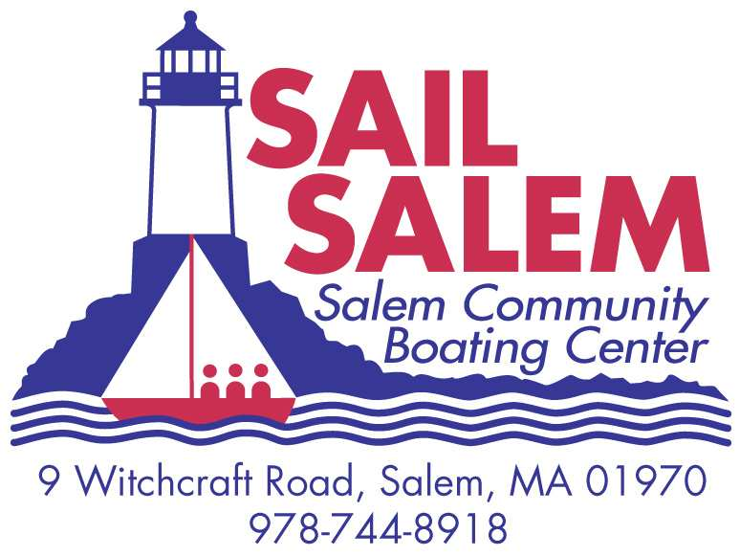

This form certifies that my child __________________________________ (Print child’s name here) is comfortable swimming 75 yards, and has done so in the presence of a certified instructor or life guard on this _____(day), _____ (Month), 2013

at the_____________________________ (facility name).

___________________________________________(Parent Signature)

___________________________________________(Print Parent’s Name)

___________________________________ (Certified Instructor or Life Guard Signature)

___________________________________ (Print Instructor’s Name)

*Please bring this completed form with you on the first day. Please understand for your child’s own safety, the *Sail Salem, Inc. will not allow your child to participate in the program unless a fully completed swim certificate has been received*.  Both a certified instructor **or** life guard ***and*** a parent must sign the form. Thank You.

**If you are looking for a place to have the swim test, the Salem YMCA will test your child at no charge at their facility with their life guards. Just bring this form to a life guard and ask to be tested. The hours for testing are 5:00 a.m. – 9:45 p.m. Monday through Friday; Saturdays 6:00 a.m. to 6:45 p.m. and Sunday 7:00 a.m. to 5:45 a.m.